**ASSIGNMENT 5**

Working with e-commerce Model:

Placing orders and getting it delivered in 2 hrs.

**COURSE:** INFO5100 37892

Application Engineering & Development

**PROFESSOR:**

Khaled Bugrara

**SUBMITTED BY:**

Ajay Goel - 001897443

Ankit Yadav - 001271369

Himani Solanki - 001899580

**The Virtual Mall Model**

In our virtual mall model, there are a lot of directories we are dealing with, which goes as follows:

* **Suppliers Directory:** This consists of the list of all suppliers which are going to deal with us. The attributes which take into consideration are Supplier Name, Supplier Location, Supplier Zip code and the Product Directory.
* **Customer Directory:** This will collect all the customers under one directory. The attributes this will have are First Name, Last Name, Location, Mobile Number, Credit Card details, and Mode of payment they want to choose.
* **Master Order Catalog:** This catalog will be holding all the order’s list. This is going to be the most super order catalog as it will have the record of all suppliers’ order list placed by the customers.
* **User Account Directory:** This directory will be collecting all the user’s login credentials and thus will come into play when the user login to the portal and the verification of it is to be done.

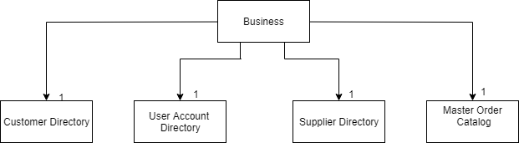

The Supplier Directory is further segregated into:

* **Product Directory:** This directory will keep the record of all the products a supplier is supplying on the website. This will hold the Product Name, Product Price, Product Model Number, Product availability as its attributes.

The Master Order Catalog is further described as:

* **Order Item List:** This will count all the orders which is being placed by the customers to various supplier and their products with the various unit counts.

The complete object model of our application goes as follows:

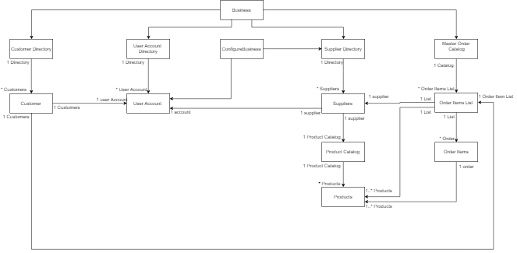

The performance of our application consists of various steps which goes as listed below:

1. Admin
2. Suppliers
3. Customers

**The Main Panel**

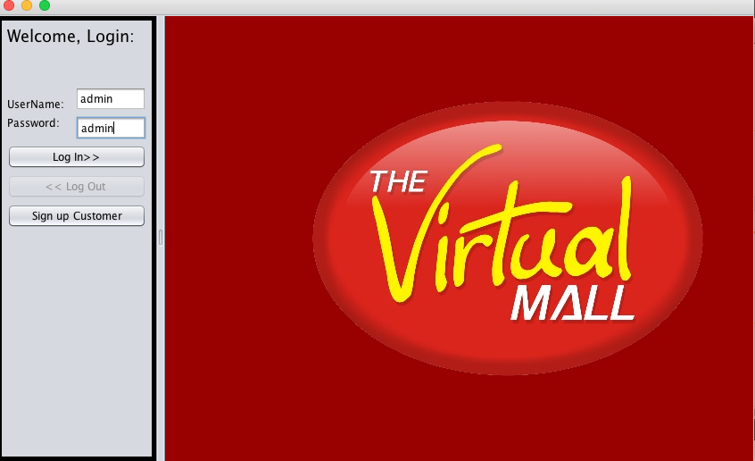

* **Admin**

1. We have created a configureBusiness class in which we have predefined the admin.
2. The admin is going to come and login to the portal with the login credentials.
3. The admin will be redirected to the admin work area where he can manage suppliers and customers.
4. As the admin goes in the manage suppliers plane he can perform two things, add suppliers and manager user accounts of the suppliers.
5. The admin only can add supplier. The fields he will be taking into considerations are supplier’s name, his work location and the zip code.
6. The manage user account will be used by the admin to assign the user credentials to the suppliers he will be dealing with.
7. The suppliers need a user account to manage their product catalog.
8. The admin should also have the records of all the customers dealing with the products of the suppliers under his roof.

**Admin Work Area Panel**

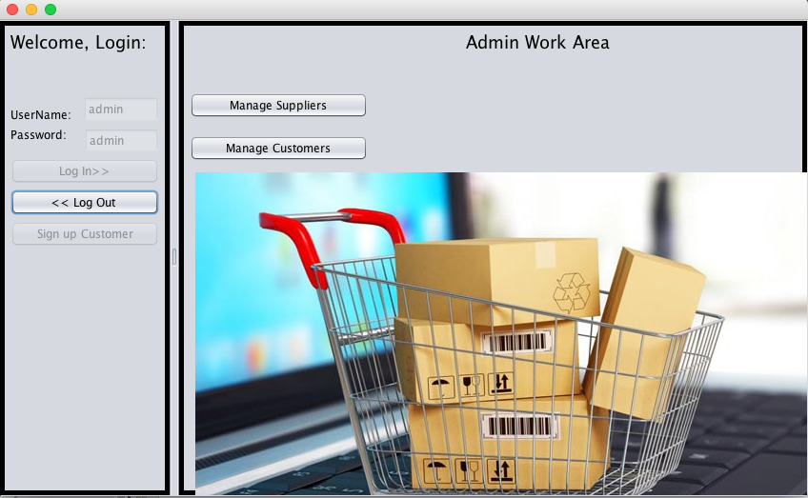

**Manage Suppliers Panel**

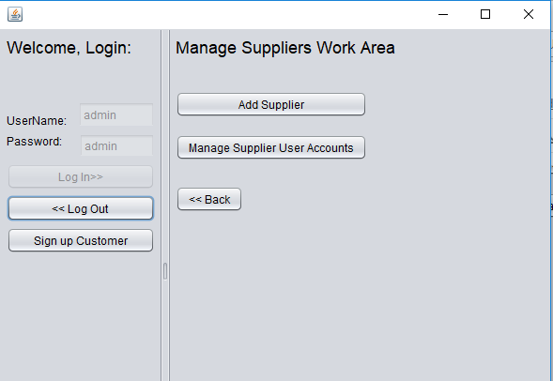

**Manage Customer Panel**

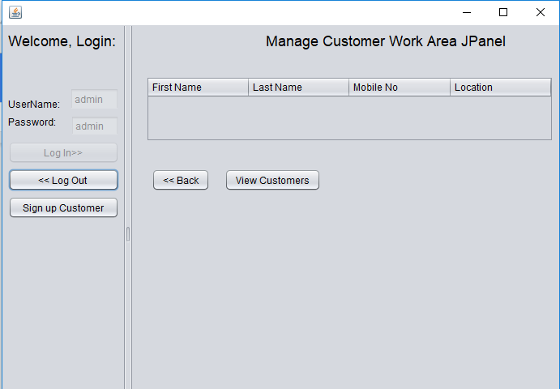

* **Suppliers**

1. The suppliers log in to the portal.
2. The login credentials will be checked then the supplier will be redirected to his respective work area.
3. The supplier work area will be dealing with managing the products, managing the orders placed by the customer to the supplier and manager his account.
4. When the supplier goes to the manage product panel, he can see the list of products with the product image he deals with and can perform various operations like adding a product, view product details, delete a product, perform a custom search for any product.
5. The supplier will be directed to add product panel if he wants to add a new product in his product catalog. The supplier needs to enter the name, price, available units, image of the product and the category of the product from the combo box.
6. The custom search panel requires the product id through which the details of that product will be displayed.
7. The supplier can view the details of a product by selecting the product from the table and hit the view details button.
8. The view details panel also have an additional update button through which he can update the details of that product.
9. The supplier can delete a product by simply selecting and then clicking on the delete button. A confirmation window will appear asking him that is he sure about his decision or not.
10. The suppliers can manage the orders being placed by the customers through the manage order panel.
11. The manage order panel will be having the list of all the orders being placed by the customers.
12. The suppliers can manage the order status and can also cancel the order from this panel. The cancel order will be done if the supplier finds the product condition is defected. Once the order is been delivered the supplier cannot cancel the order.
13. The supplier can also manage his account details from the manage account panel from his work area. In that he can update his details if required.

**Supplier Work Area Panel**

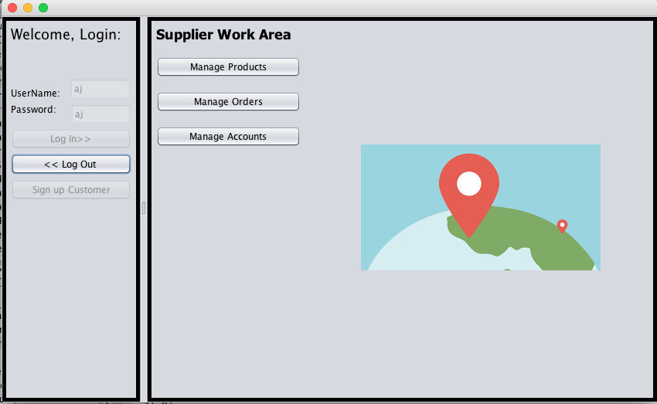

**Manage Product Catalog Panel**

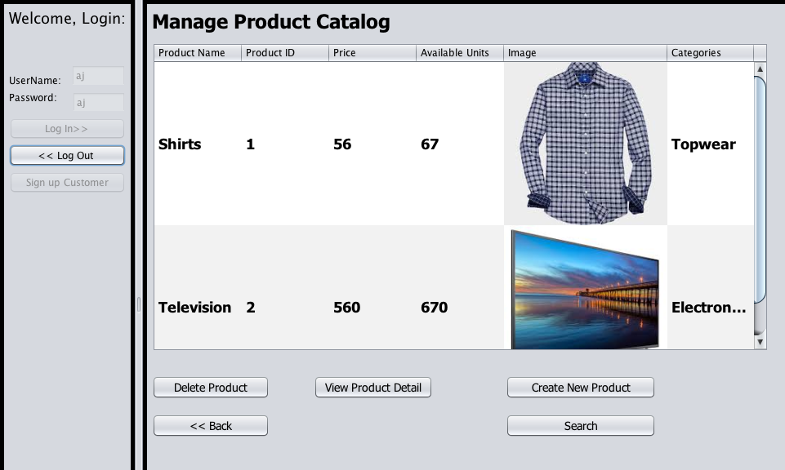

**Create new Product Panel**

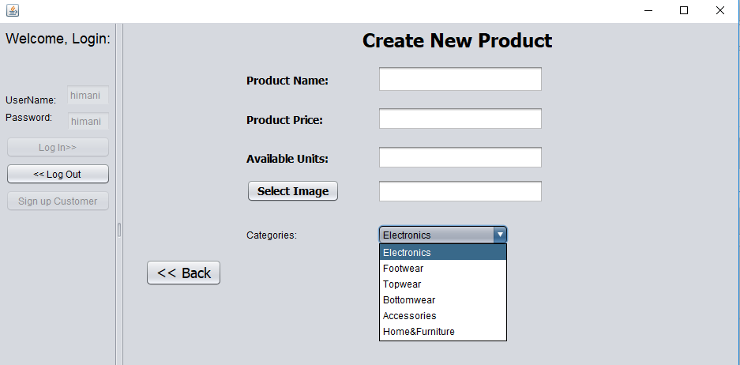

**Manage Orders Panel**

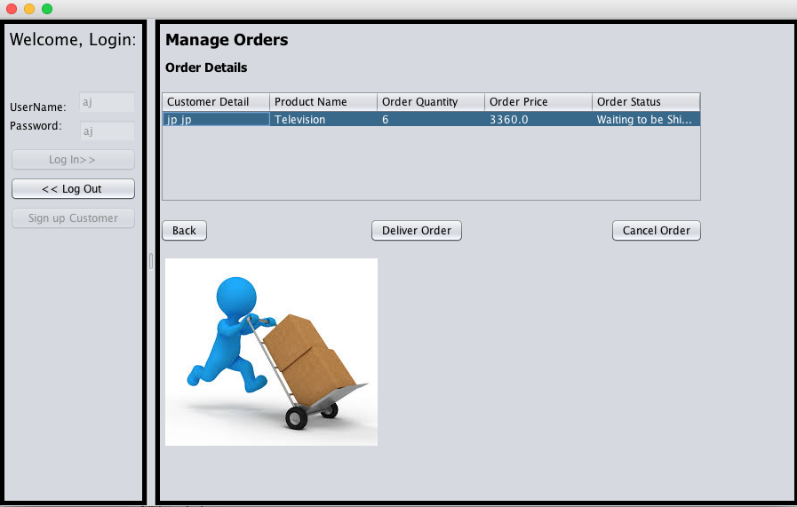

* **Customers**

1. The customer needs to login to the portal for placing orders.
2. If we have an all new customer then he needs to sign up and then login to be able to place orders.
3. The customer login credentials will be verified and then only he will be able to browse products and order some for himself.
4. The customer work area will consist of three things, i.e., manage account, manage orders and browse products.
5. The customer can manage his account details by going to the manage account panel where he can view and update his details by simply clicking on update button.
6. The customer can also see the list of orders he has placed so far and what is the order status for recently placed order, **like is it approved for delivery by the supplier or not etc.**
7. The customer can browse the products by clicking on the browse product button. The customer will only be able to see those products which the supplier in his location are selling.
8. When the customer is redirected to the browsing product panel he can easily see the products,

Search can be done in following ways:

* **Category Search:** Customer can simply search products based on category.
* **Category and Item Name:** Customer can enter the item name and category and see the results accordingly

1. The customer can simply select the product from the table and click on buy product.
2. The buy product button will take the customer to product cart panel where he can enter the number of units he wants of that product.
3. After the customer has decided the number of units he wants to buy he can click on place order button where he will be directed to the payment panel.
4. The customer will be able to see the total amount of the product according to the number of units he is buying.
5. The customer can review the payment amount and click on finish payment to complete the order.
6. The customer will get a thank you screen with the confirmation of the order details and through that he can either go to his work area or can go and browse more products.
7. The customer will receive the product once the supplier approves the delivery of the order placed.

**Login for Customers Panel**

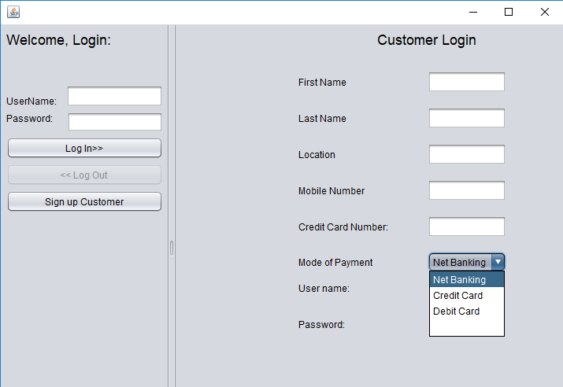

**Customer Work Area Panel**

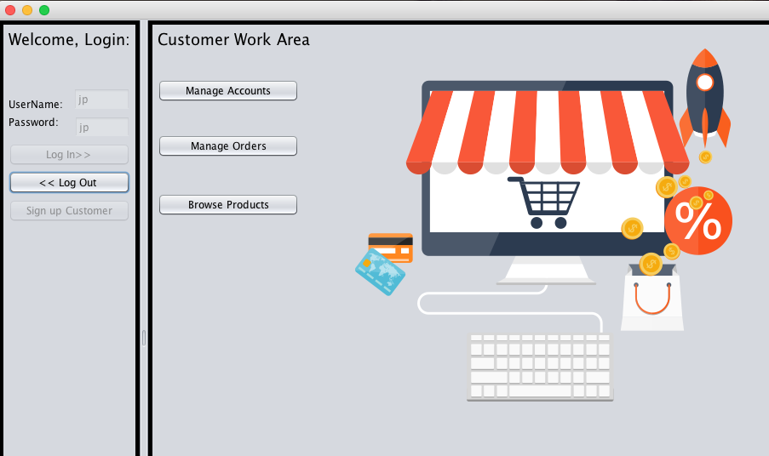

**Browse Products Panel**

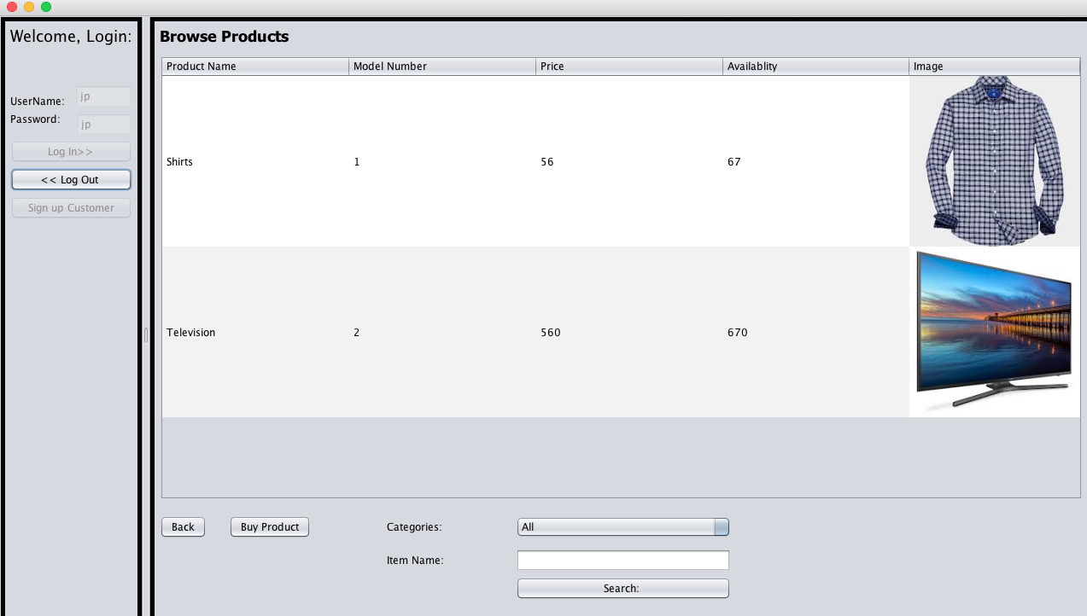

**Product Cart Panel**

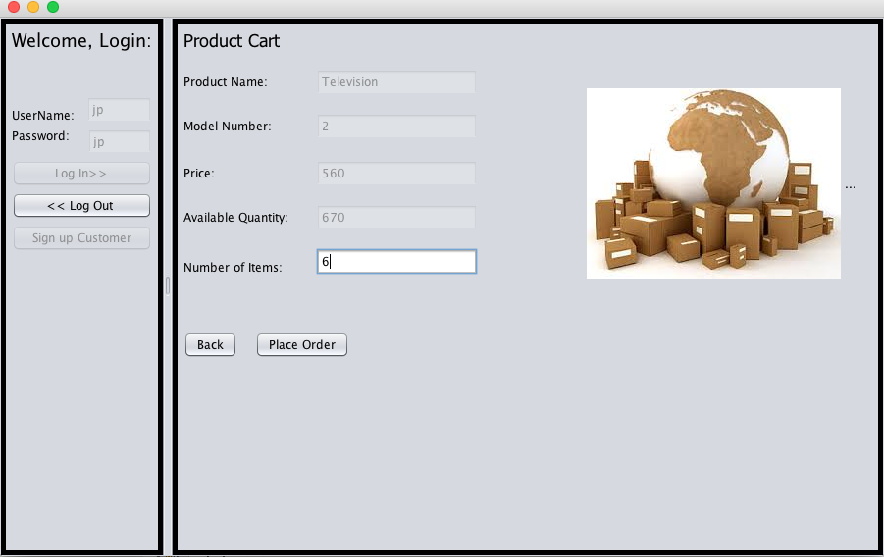

**Order Payment Panel**

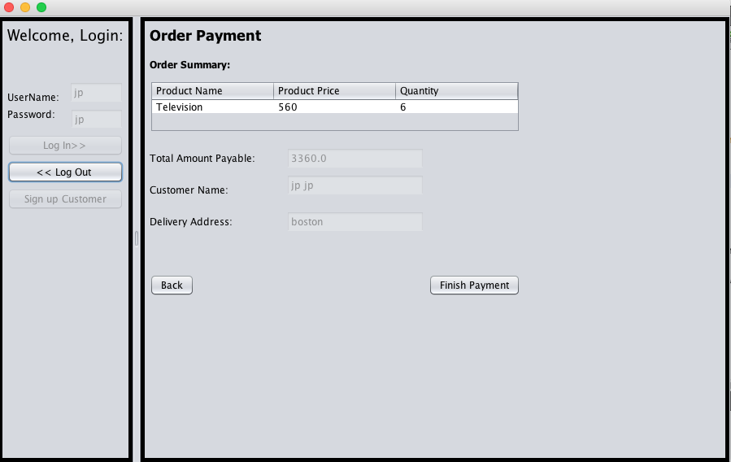

**Order Details Panel**

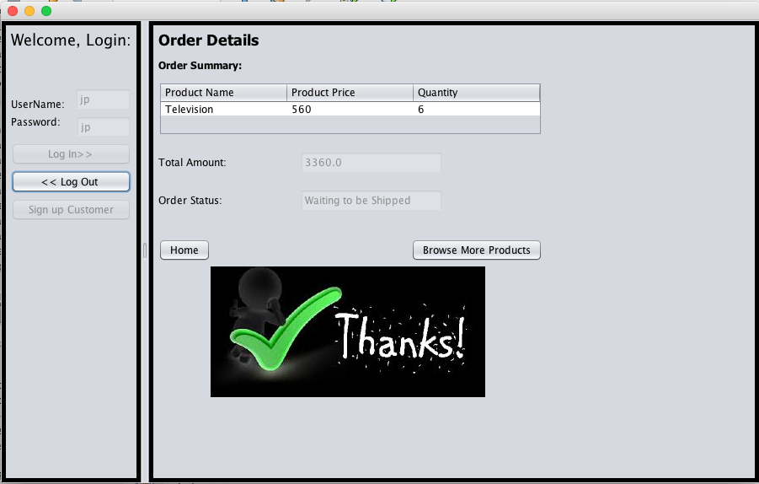

**Manage Past Order Panel**

